Mail Server

27/04/2015

Description:
The mail server just handle mail server components events and retrieving
and storing jobs.

Mail server components:
- SMTP Server
- POP3
- IMAP4
- WebMail

Features:
Mail box size limit.
Support XML and MSSQL Database.
IP Access Filtering.

SMTP Server:
It is an email server that use to send email.it store your message and ensure that your message are delivered or return with failure.
The msg sent is SMTP mail should necessary be in 7bit ASCII format.

It consist of Two Independent Parts.

- SMTP Server-pick up the msg from queue and process them.
- Queue Manager-Receive Mail Msg from network client and put them into queue.

Performance Tuning:

Setting timeout for quickly receive msg[SMTP Server].
Setting “Interval” attribute,specify queue will be scan for unfinished message.
Setting “Checkpoint” attribute of “ FILEMAILQUEUE” for remove msg them permanently from the queue.

SMTP Process:

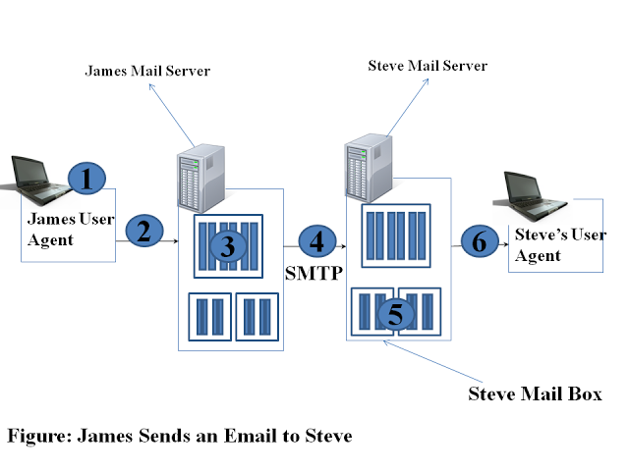

- User send mail to user mail server and message get place in queue.
- Then it open the Tcp connection with SMTP Server in the receipent side.
- After Hand shaking process the SMTP User send mail to TCP Connection.
- The Receipent side receive msg and placed in the mail box.

Sample code:

MailMessage mailMessage = new MailMessage();
mailMessage.To.Add("your.own@mail-address.com");
mailMessage.From = new MailAddress("another@mail-address.com");
mailMessage.Subject = "ASP.NET e-mail test";
mailMessage.Body = "Hello world,\n\nThis is an ASP.NET test e-mail!";
SmtpClient smtpClient = new SmtpClient("smtp.your-isp.com",port number);//port number=25;
smtpClient.Credentials=new System.Net.NetworkCredential("username", "password");
smtpClient .EnableSsl = true;
smtpClient.Send(mailMessage);
Response.Write("E-mail sent!");

attach one or several files:
mailMessage.Attachments.Add(new Attachment(Server.MapPath("~/image.jpg")));

send to more than one person at the same time:
mailMessage.To.Add("your.own@mail-address.com");
mailMessage.To.Add("another@mail-address.com");

set a name for the sender:
mailMessage.From = new MailAddress("me@mail-address.com", "My Name");

send HTML e-mails: instead of the default plaintext mails, to use more complicated layouts.
mailMessage.IsBodyHtml =true;
mailMessage.Body = "Hello <b>world!</b>";

use the CC and BCC fields:
mailMessage.CC.Add("me@mail-address.com");
mailMessage.Bcc.Add("me2@mail-address.com");

set the priority of an e-mail:
mailMessage.Priority = MailPriority.High;

28/04/2015

Task:how to find out the errors and get notification in smtp ?

SMTP Status Code:
It is outcome of sending maiil using smtp class.

Namespace : System.Net.Mail;

Status code -- Description
Ok - email send successfully.

ServiceNotAvailable -- The SMTP service is not available.

ClientNotPermitted --The client was not authenticated or is not allowed to send mail using the specified SMTP host.

SyntaxError -- The syntax used to specify a command or parameter is incorrect..

MustIssueStartTlsFirst -- using a non-TLS connection.

TransactionFailed -- The transaction failed.

GeneralFailure -- The transaction could not occur. You receive this error when the specified SMTP host cannot be found.

ClientNotPermitted -- The client was not authenticated or is not allowed to send mail using the specified SMTP host.

SmtpFailedRecipientException:
Represents the exception that is thrown when the SmtpClient is not able to complete a Send or SendAsync operation to a particular recipient.

DeliveryNotificationOptions:
Describes the delivery notification options for e-mail.

None-- No notification.
OnSuccess -- Notify if the delivery is successful.
OnFailure -- Notify if the delivery is unsuccessful.
Delay -- Notify if the delivery is delayed
Never -- Never notify.
Example :
mailMessage.DeliveryNotificationOptions = System.Net.Mail.DeliveryNotificationOptions.Never;

To access the remote certificate or trusted certificate from code:
ServicePointManager.ServerCertificateValidationCallback = delegate(object s, X509Certificate certificate, X509Chain chain, SslPolicyErrors sslPolicyErrors) { return true; };

29/04/2015

SMTP COMMANDS:
HELO -- Initiates a conversation with the mail server.
Ex:
HELO mailservername
MAIL -- Sending the mail.
Ex:
MAIL FROM<youremailaddress>
RCPT -- Recieving the mail.
Ex:
RCPT TO< sendermailaddress>
DATA -- send the text (or body) of the message. message text must end with the following five letter sequence: "\r\n.\r\n."
Ex:
DATA
QUIT -- conversation is over.

SEND -- Sends a message to a user.

list of reply codes:
220-- The server is ready.

250-- The requested action was completed.

550-- The mailbox that you are trying to reach can't be found.

554-- The mail transaction has failed for unknown causes.

553 --Requested action not taken: mailbox name not allowed (e.g. mailbox syntax incorrect)

30/04/2015

Difference between imap and pop3?
IMAP(Internet Mail Access Protocol) | POP (PostOffice Protocol)
The IMAP protocol allows the user to keep all messages on the server. It constantly synchronizes the e-mail program with the server and displays what messages are currently present. All the actions performed on the messages (reading, moving, deleting...) will be done directly on the server. | The POP protocol is set to download all the messages from the e-mail server onto your computer. This means that all the actions performed on the messages (reading, moving, deleting...) will be performed on one's computer.  Because everything is kept on the user’s computer, the user will not be able to reopen messages from any location other than the computer where the messages have been downloaded.
the user will be able to access the e-mail in the inbox from any computer in the world connected to the Internet | Once e-mail is downloaded it can be accessed only using the same computer.

POP3 COMMANDS:
The commands used to retrive mail from
POP3 server by an email client with single line response from mail server.

Commands:

USER- Specify the user name.

PASS-enter the password.

STAT-number of messages.

LIST-each message number with bytes.

RETR-get the particular mail using mail number.

DELE-delete the mail

REST-undelete the mail

TOP -retrieve the part of the message.

QUIT-simply log off

All responses from the server will start with one of the following:

+OK
-ERR

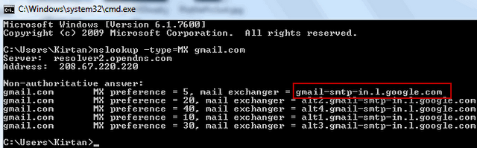

Dealing with a 553 error
To solve the problem, you need to "verify" the email address that's been blocked by confirming that the account is genuine and known to you. First, you add details of the blocked account to your BT Yahoo! webmail settings. This then triggers a verification email to the email account you want unblocking. When you verify the email, BT Yahoo! knows everything is OK and will unblock the account.

To identify the domain name:

using ARSoft.Tools.Net.Dns;
varresponse = DnsClient.Default.Resolve("gmail.com", RecordType.Mx);var records = response.AnswerRecords.OfType<MxRecord>();foreach (var record inrecords) { Console.WriteLine(record.ExchangeDomainName);}

